**SPH3U 8.3 Wave Characteristics**

1. **Geometric wave characteristics**

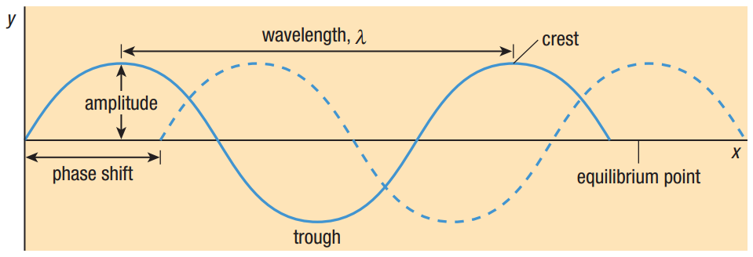

|  |  |
| --- | --- |
| Amplitude: |  |
| Wavelength: |  |
| Phase: |  |
| Phase shift: |  |

1. **Time-based wave characteristics**

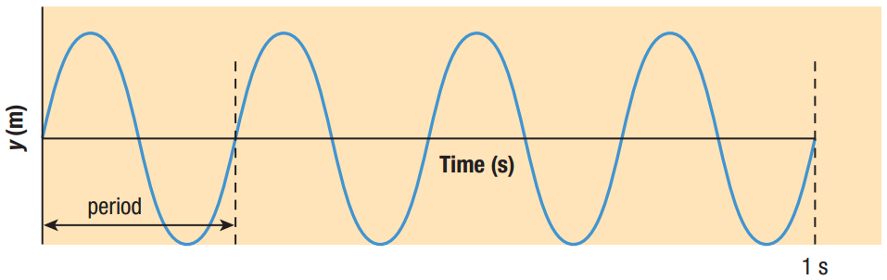

|  |  |  |
| --- | --- | --- |
| Period: |  | |
| Frequency: |  | |
| equation |  |  |
| Wave speed: |  | |
| equation |  | |

|  |  |
| --- | --- |
| Simple harmonic motion (SHM): |  |

**Homework:** page 387: #1, 3-4